Lisbon Elementary Hybrid Schedule

February 22, 2021
All student schedules will change effective Monday, March 1, regardless of whether the student is returning in-person or remaining virtual.
Please click here for Lisbon Elementary's schedule.

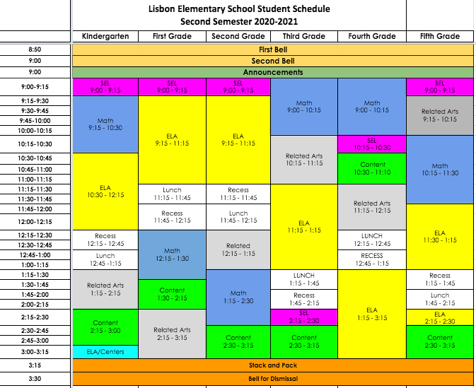

Lisbon Elementary School | 15901 Frederick Road Woodbine, MD 21797 | (410) 313-5506 | les.hcpss.org

