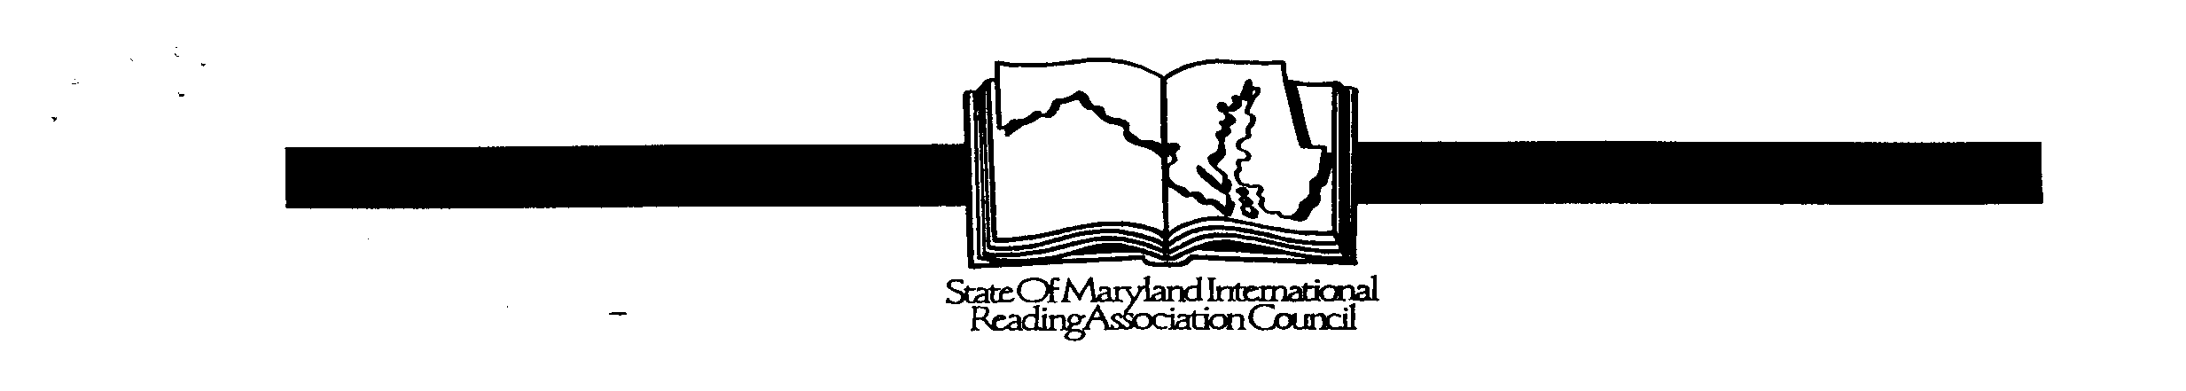

YOUNG AUTHORS’ CONTEST SoMIRAC 2017-2018

COVER SHEET

Please print clearly- information will be used for publication and certificates
Student/Author’s Name: | Student’s name as it should appear in the publication
Student/Author’s  Home Address: | (Street, city, state. zip)

Student/Author’s

Home Phone:

Email Address:

School Name/ Address:  (Full Address with zip code) | Lisbon Elementary School  15901 Frederick Rd  Woodbine, MD 21797
Grade:  Teacher: First/Last Name | Grade: ______  Mr., Mrs., Ms. _____________________________________  (circle one)

Teacher Email:

** Must be included
Local Reading Council: | Howard County Reading Council
Title of Entry: | Title:  Circle one: POEM SHORT STORY

Permission for Publication

I, _________________________________________, give permission for SoMIRAC
Print first and last name
representatives to reproduce my child’s work in an anthology of writing, in the event he/she becomes a state winner.

Student Signature: _____________________________________ Date:_______________

Parent Signature: _____________________________________ Date: _______________

Teacher Signature: ___________________________________ Date: _______________

